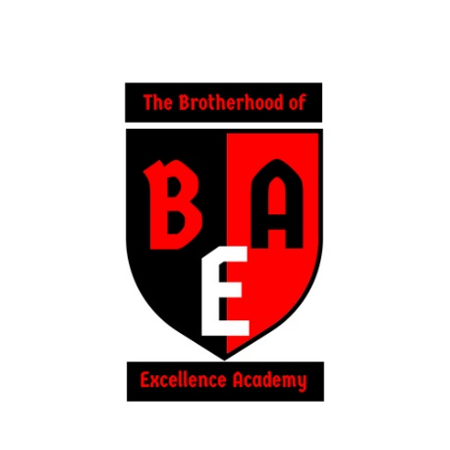
The Brotherhood of Excellence Academy
Board of Director’s Agenda
Teleconference
December 13, 2018
7:00pm Agenda
- Call to Order
- Opening Prayer
- Review and approval of August 2, 2018 Minutes
- Dismissal of Roberts Rules of Order
- Board Member Introductions
- Review of Mission and Vision
- Officer Elections
  - Current Officers
    - Chameeka N. Smith- Board Chairperson – Founding Board Member
    - Sharon Thomas- Board Secretary – Founding Board Member
    - Discuss revisions of the Board of Directors officers (Two new members)
      - Proposed Positions:
        - Sharon Thomas- Board Chairperson (Founding Board)
        - Tamala Anderson- Secretary (Founding Board)
        - Zonja Glover- Treasurer (Founding Board)
        - Chameeka N. Smith -Executive Director
- Bylaw Updates
- Strategic Plan 2018-2019 updates
  - https://brotherhoodeacadem.wixsite.com/brotherhood
- Setting up Financial Account with Board Treasurer
  - The organization will work to secure a Board treasurer for the organization and set up an account with two signature requirements for financial transactions
  - CPA Discussion Notes
- 501(c)(3) application update – 1023 Form
- Completed Board Member Paperwork
- Special Event- 2019
  - Black Male Conference - “Breaking the school to Prison pipeline” conference
  - Saturday Enrichment Fall 2019
  - Committee Planning
- Long Range projections
  - Fall 2019- Saturday Enrichment (10 months) (6th-8th grade)
  - Summer 2020- Summer Camp (6th-8th grade)
  - Fall 2020- Saturday Enrichment and After School Programming (6th-8th grade)
  - Summer 2021-Summer Camp (6th-8th grade)
  - Fall 2021- 9th grade academy
  - Conference, Seminars, Workshops, Retreats
- Next Steps
  - Nonprofit Status Approval (Determination Letter)
  - Nonprofit Insurance
  - Fundraising with for profit organization
  - Treasurer’s name on bank account
  - High Quality Saturday Enrichment Program
  - Grant Writing
- Next Meetings
  - April 11, 2019 at 7:00pm
  - August 1, 2019 at 7:00pm
- Questions/Concerns
- Prayer
- Adjourn

